
Project Title: Program for a restaurant ordering and feedback system

NAME : SHUMAILA ARIF(68279)

PROGRAM: BS CYBERR SECURITY

COURSE: PROGRAMMING FUNDAMENTAL LAB

SUBMITTED TO: SIR SHAHZAIB ANSARI

Background / Theory:
The traditional method of manually taking restaurant orders and feedback often leads to inefficiency, delays, and record-keeping errors. This project introduces a C-based automated restaurant system designed to manage customer orders, payments, and feedback seamlessly. It applies core programming concepts such as modularity, file handling, loops, arrays, and conditionals to simulate a real-world restaurant experience in a console environment.

Procedure / Methodology:
The project was developed using the C programming language. The approach includes:
- Designing structured menus for food and drinks.
- Accepting orders with multiple options (sizes and quantities).
- Implementing validation for user input.
- Generating bills and handling payment logic.
- Collecting customer feedback.
- Writing order and feedback data to text files using file handling functions.
The project uses modular programming with separate functions for order saving, feedback saving, and main program logic.
- Objective:
The objective of this program is to simulate a restaurant ordering and feedback system where users can:
- Place Orders: Select items from the menu, calculate bills, and process payments.
- Provide Feedback: Rate the service and leave comments.
- Save Records: Store order details in orders.txt and feedback in feedback.txt.
It automates order management, improves record-keeping, and enhances customer experience.
- Project Overview:
- Problem to Solve:
Automate restaurant operations by streamlining order management, bill calculation, feedback collection, and record-keeping, eliminating manual errors.
- Purpose and Functionality:
Provide an interactive system where users can:
  - Place orders (main dishes, drinks, desserts).
  - Calculate and pay bills.
  - Provide ratings and feedback.
  - Save orders and feedback to files.
- Modules and Functions:
- Main Modules: Ordering, payment, feedback, file management.
- Key Functions:
  - saveOrderToFile(int user, int userBill): Saves order details.
  - saveFeedbackToFile(int user, int rating, char feedback[]): Saves feedback.
- Justification for Modular Programming:
- Reusability: Common tasks (e.g., saving files) as functions.
- Separation of Concerns: Each module handles a specific task.
- Maintainability: Easy to update and debug.
- Lab Purpose & Learning Outcomes:
- Practice modular programming, loops, conditions, arrays, and file handling.
- Build a real-world application with structured design.
- Techniques Used:
- Loops, arrays, switch cases, functions, file handling, and string operations.

Analysis:
The program ensures input validation, modular structure, and logical flow. It uses arrays for price lists and applies loops for iterative order-taking. Conditional statements handle edge cases (e.g., invalid size or quantity). File handling is used to store persistent records, demonstrating practical applications of file I/O.
Flowchart:
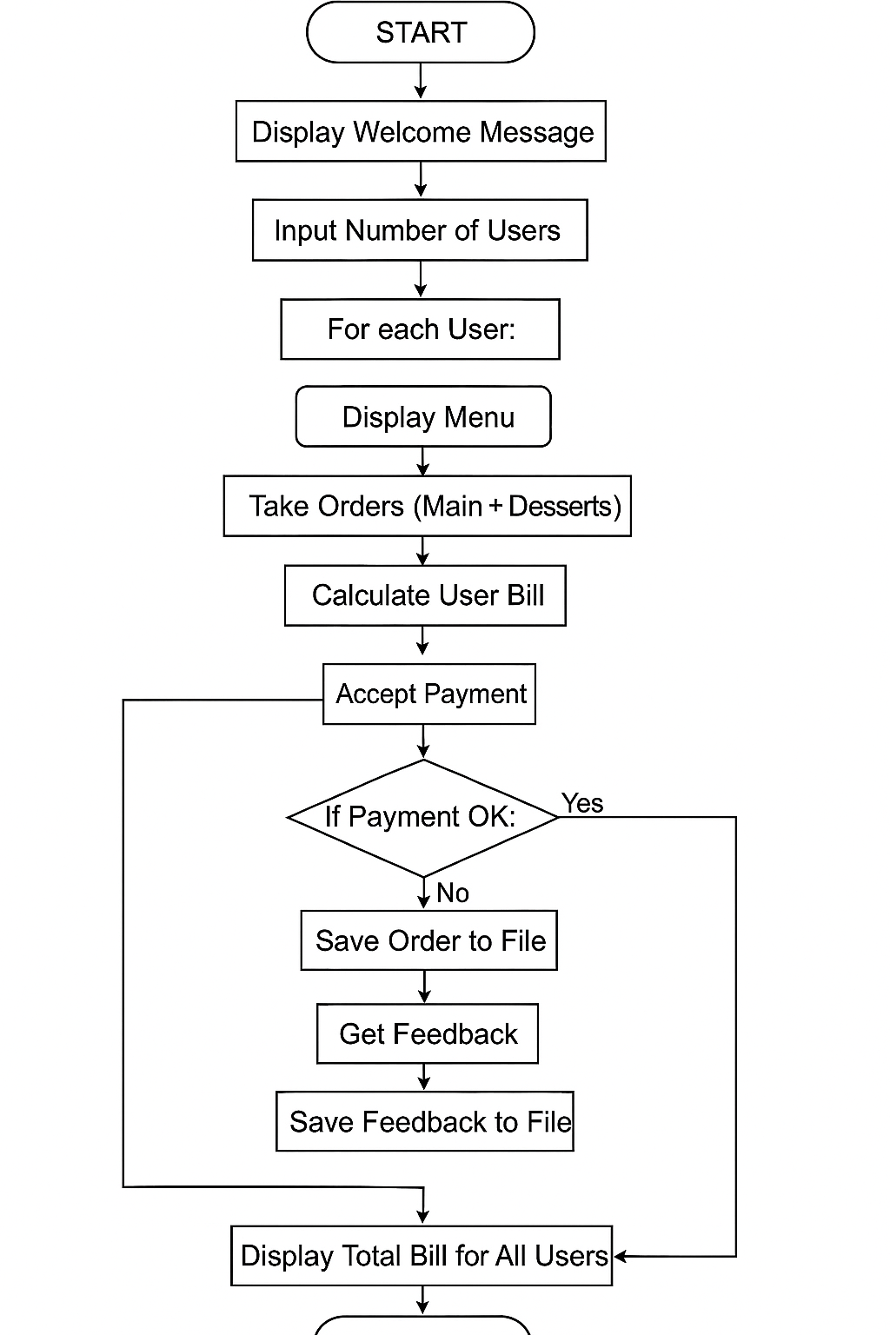

Design Phase:
1. Pseudocode
START
PRINT "Welcome to Birbal's Kitchen!"
INPUT userCount
SET totalBill = 0
FOR user FROM 1 TO userCount:
SET userBill = 0
// Main Menu
WHILE TRUE:
DISPLAY Main Menu
INPUT choice
IF choice == 0: BREAK
PROCESS main menu choice and update userBill
// Dessert Menu
WHILE TRUE:
DISPLAY Dessert Menu
INPUT dessertChoice
IF dessertChoice == 0: BREAK
PROCESS dessert choice and update userBill
// Payment
PRINT "User [user], your total bill: Rs [userBill]"
WHILE TRUE:
INPUT payment
IF payment >= userBill:
PRINT "Payment successful! Change: Rs [payment - userBill]"
BREAK
ELSE:
PRINT "Insufficient payment. Try again."
// Feedback
INPUT rating, feedback
SAVE feedback to file
SAVE order to file
totalBill += userBill
PRINT "Total bill for all users: Rs [totalBill]"
PRINT "Thank you for dining with us!"
END

2. Module Plan:
- Input Module
  - Collects user count, menu choices, sizes, quantities, payment, and feedback.
- Processing Module
  - Validates inputs (menu options, sizes, quantities, payment).
  - Calculates individual and total bills.
- Output Module
  - Displays menus, bills, feedback prompts, and thank-you messages.
  - Outputs payment status and change.
- File Management Module
  - Saves order details to orders.txt.
  - Saves feedback to feedback.txt.

3. Function Details
Function | Input Parameters | Output | Purpose
saveOrderToFile() | int user, int userBill | None | Saves the total bill for a user to the order file.
saveFeedbackToFile() | int user, int rating, char feedback[] | None | Saves user feedback (rating and comments) to the feedback file.
main() | None | int (return value) | Manages the entire flow of the program, coordinating all modules.
Input Handling (Inline) | User choices and quantities | None | Collects user input for menu choices, size, and quantity.
Validation (Inline) | User input values | Validated user input | Ensures user input is within acceptable ranges.
Code
#include <stdio.h>

void saveOrderToFile(int user, int userBill);
void saveFeedbackToFile(int user, int rating, char feedback[]);

int main() {
int userCount; // Number of users placing orders
int totalBill = 0; // Total bill for all users

// Item prices
int biryaniPrices[3] = {250, 400, 600}; // Small, Medium, Large
int karahiPrices[3] = {600, 1200, 1600}; // Small, Medium, Large
int tikkaPrices[3] = {300, 450, 600}; // Small, Medium, Large
int drinkPrices[4] = {50, 100, 180, 250}; // 250ml, 500ml, 1L, 1.5L
int dessertPrices[3] = {100, 150, 200}; // Ice Cream, Gulab Jamun, Cake

printf("Welcome to Birbal's Kitchen!\n");
printf("Enter the number of users placing orders: ");
scanf("%d", &userCount);

for (int user = 1; user <= userCount; user++) {
int userBill = 0; // Total bill for the current user

printf("\nUser %d, place your order:\n", user);

// Ordering main dishes and drinks
while (1) {
printf("\n===== MENU =====\n");
printf("1. Biryani (Small: Rs 250, Medium: Rs 400, Large: Rs 600)\n");
printf("2. Karahi (Small: Rs 600, Medium: Rs 1200, Large: Rs 1600)\n");
printf("3. Chicken Tikka (Small: Rs 300, Medium: Rs 450, Large: Rs 600)\n");
printf("4. Drinks (250ml: Rs 50, 500ml: Rs 100, 1L: Rs 180, 1.5L: Rs 250)\n");
printf("0. Proceed to Desserts\n");
printf("=================\n");

printf("Enter your choice (or 0 to proceed to desserts): ");
int choice;
scanf("%d", &choice);

if (choice == 0) {
break;
}

int size, quantity, maxQuantity = 10;
switch (choice) {
case 1: // Biryani
printf("\nYou chose Biryani.\n");
printf("Select size:\n1. Small (Rs 250)\n2. Medium (Rs 400)\n3. Large (Rs 600)\n");
printf("Enter your choice: ");
scanf("%d", &size);
if (size >= 1 && size <= 3) {
printf("Enter quantity (1 to %d plates): ", maxQuantity);
scanf("%d", &quantity);
if (quantity >= 1 && quantity <= maxQuantity) {
userBill += biryaniPrices[size - 1] * quantity;
printf("%d Biryani(s) (Size: %s) added to your order.\n",
quantity,
(size == 1) ? "Small" : (size == 2) ? "Medium" : "Large");
} else {
printf("Invalid quantity! Please enter a number between 1 and %d.\n", maxQuantity);
}
} else {
printf("Invalid size. Try again.\n");
}
break;

case 2: // Karahi
printf("\nYou chose Karahi.\n");
printf("Select size:\n1. Small (Rs 600)\n2. Medium (Rs 1200)\n3. Large (Rs 1600)\n");
printf("Enter your choice: ");
scanf("%d", &size);
if (size >= 1 && size <= 3) {
printf("Enter quantity (1 to %d plates): ", maxQuantity);
scanf("%d", &quantity);
if (quantity >= 1 && quantity <= maxQuantity) {
userBill += karahiPrices[size - 1] * quantity;
printf("%d Karahi(s) (Size: %s) added to your order.\n",
quantity,
(size == 1) ? "Small" : (size == 2) ? "Medium" : "Large");
} else {
printf("Invalid quantity! Please enter a number between 1 and %d.\n", maxQuantity);
}
} else {
printf("Invalid size. Try again.\n");
}
break;

case 3: // Chicken Tikka
printf("\nYou chose Chicken Tikka.\n");
printf("Select size:\n1. Small (Rs 300)\n2. Medium (Rs 450)\n3. Large (Rs 600)\n");
printf("Enter your choice: ");
scanf("%d", &size);
if (size >= 1 && size <= 3) {
printf("Enter quantity (1 to %d pieces): ", maxQuantity);
scanf("%d", &quantity);
if (quantity >= 1 && quantity <= maxQuantity) {
userBill += tikkaPrices[size - 1] * quantity;
printf("%d Chicken Tikka(s) (Size: %s) added to your order.\n",
quantity,
(size == 1) ? "Small" : (size == 2) ? "Medium" : "Large");
} else {
printf("Invalid quantity! Please enter a number between 1 and %d.\n", maxQuantity);
}
} else {
printf("Invalid size. Try again.\n");
}
break;

case 4: // Drinks
printf("\nYou chose Drinks.\n");
printf("Select size:\n1. 250ml (Rs 50)\n2. 500ml (Rs 100)\n3. 1L (Rs 180)\n4. 1.5L (Rs 250)\n");
printf("Enter your choice: ");
scanf("%d", &size);
if (size >= 1 && size <= 4) {
printf("Enter quantity (1 to %d bottles): ", maxQuantity);
scanf("%d", &quantity);
if (quantity >= 1 && quantity <= maxQuantity) {
userBill += drinkPrices[size - 1] * quantity;
printf("%d Drink(s) (Size: %s) added to your order.\n",
quantity,
(size == 1) ? "250ml" : (size == 2) ? "500ml" : (size == 3) ? "1L" : "1.5L");
} else {
printf("Invalid quantity! Please enter a number between 1 and %d.\n", maxQuantity);
}
} else {
printf("Invalid size. Try again.\n");
}
break;

default:
printf("Invalid choice. Try again.\n");
}
}

// Ordering desserts
while (1) {
printf("\n===== DESSERT MENU =====\n");
printf("1. Ice Cream (Rs 100)\n");
printf("2. Gulab Jamun (Rs 150)\n");
printf("3. Cake (Rs 200)\n");
printf("0. Finish Desserts\n");
printf("========================\n");

printf("Enter your choice (or 0 to finish desserts): ");
int dessertChoice;
scanf("%d", &dessertChoice);

if (dessertChoice == 0) {
break;
}

int quantity, maxQuantity = 10;
if (dessertChoice >= 1 && dessertChoice <= 3) {
printf("Enter quantity (1 to %d servings): ", maxQuantity);
scanf("%d", &quantity);
if (quantity >= 1 && quantity <= maxQuantity) {
userBill += dessertPrices[dessertChoice - 1] * quantity;
printf("%d %s(s) added to your order.\n",
quantity,
(dessertChoice == 1) ? "Ice Cream" : (dessertChoice == 2) ? "Gulab Jamun" : "Cake");
} else {
printf("Invalid quantity! Please enter a number between 1 and %d.\n", maxQuantity);
}
} else {
printf("Invalid choice. Try again.\n");
}
}

printf("\nUser %d, your total bill is Rs %d.\n", user, userBill);
saveOrderToFile(user, userBill);

printf("Please pay your bill. Enter payment amount: ");
int payment;
scanf("%d", &payment);

if (payment >= userBill) {
printf("Payment successful! Change: Rs %d\n", payment - userBill);
totalBill += userBill;

// Feedback
printf("\n===== Feedback Section =====\n");
printf("Rate our service (1-5): ");
int rating;
scanf("%d", &rating);
printf("Leave a comment: ");
char feedback[100];
getchar(); // Consume newline
fgets(feedback, 100, stdin);
saveFeedbackToFile(user, rating, feedback);
printf("\nThank you for your feedback!\n");
} else {
printf("Payment failed. Please try again.\n");
}
}

printf("\nAll orders completed. Total bill for all users: Rs %d\n", totalBill);
printf("\nThank you for dining with Birbal's Kitchen!\n");

return 0;
}

// Function to save orders to a file
void saveOrderToFile(int user, int userBill) {
FILE *orderFile = fopen("orders.txt", "a");
if (orderFile == NULL) {
printf("Error: Could not save order details to file.\n");
} else {
fprintf(orderFile, "User %d Total Bill: Rs %d\n", user, userBill);
fclose(orderFile);
}
}

// Function to save feedback to a file
void saveFeedbackToFile(int user, int rating, char feedback[]) {
FILE *feedbackFile = fopen("feedback.txt", "a");
if (feedbackFile == NULL) {
printf("Error: Could not save feedback to file.\n");
} else {
fprintf(feedbackFile, "User %d Feedback:\n", user);
fprintf(feedbackFile, "Rating: %d\nComment: %s\n", rating, feedback);
fclose(feedbackFile);
}
}

Results:
- Successfully takes multiple user orders.
- Calculates individual and total bills.
- Accepts payments and calculates change.
- Saves user-specific order and feedback data to external files.
- Provides a complete and interactive restaurant simulation

Discussion on Results:
The implementation meets all intended goals. Users are guided through the process with clear prompts. Invalid input is handled gracefully, maintaining program stability. Files orders.txt and feedback.txt effectively log data for administrative use. The modular approach makes the code easier to understand and maintain.

Concluding Remarks:
This project achieves its objective of simulating a real-world restaurant ordering and feedback system. It helps reinforce programming fundamentals such as modularity, file handling, control structures, and user input validation. It’s a practical example of how C can be used to build structured, useful console applications.
